TASK 01
#include <iostream>
using namespace std;

#define SIZE 10

class Node {
public:
string key, value;
Node* next;

Node(){}
};

class HashTable {
Node* table[SIZE];
public:
HashTable() {
for (int i = 0; i < SIZE; i++) {
table[i] = nullptr;
}
}

int hashFunction(string key) {
int hash = 0;
for (char c : key) {
hash = (hash + c) % SIZE;
}
return hash;
}

void insert(string key, string value) {
int index = hashFunction(key);
Node* newNode = new Node;
newNode->key = key;
newNode->value = value;
newNode->next = nullptr;

if (table[index] == nullptr) {
table[index] = newNode;
} else {
Node* temp = table[index];
while (temp->next != nullptr) {
temp = temp->next;
}
temp->next = newNode;
}
}

void display() {
for (int i = 0; i < SIZE; i++) {
cout << i << " -> ";
Node* temp = table[i];
while (temp != nullptr) {
cout << "( ";
cout << temp->key << ", ";
cout << temp->value << " ) -> ";
temp = temp->next;
}
cout << "nullptr" << endl;
}
}
};

int main() {
HashTable myhash;

myhash.insert("A", "aaaaa");
myhash.insert("B", "bbbbb");
myhash.insert("C", "ccccc");
myhash.insert("A", "zzzzz");

myhash.display();

return 0;
}

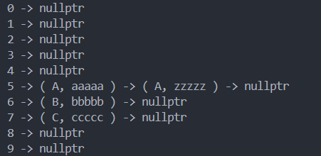
TASK 02
#include <iostream>
using namespace std;

#define SIZE 100

class Node {
public:
string key;
string value;
Node* next;

Node(){}
Node(string k, string v) : key(k), value(v), next(nullptr) {}
};

class HashTable {
Node* table[SIZE];
public:
HashTable() {
for (int i = 0; i < SIZE; i++) {
table[i] = nullptr;
}
}

int hashFunction(string key) {
int sum = 0;
for (char c : key) {
sum += int(c);
}
return sum % SIZE;
}

void Add_Record(string key, string value) {
int index = hashFunction(key);
Node* newNode = new Node(key, value);

if (table[index] == nullptr) {
table[index] = newNode;
} else {
Node* temp = table[index];
while (temp->next != nullptr) {
temp = temp->next;
}
temp->next = newNode;
}
}

void WordSearch(string key) {
int index = hashFunction(key);
Node* temp = table[index];
while (temp != nullptr) {
if (temp->key == key) {
cout << "search key " << key << ": " << temp->value << endl;
return;
}
temp = temp->next;
}
cout << "Word not found: " << key << endl;
}

void Delete_Record(string key) {
int index = hashFunction(key);
Node* temp = table[index];
Node* prev = nullptr;
while (temp != nullptr) {
if (temp->key == key) {
if (prev == nullptr) {
table[index] = temp->next;
} else {
prev->next = temp->next;
}
delete temp;
cout << "key " << key << " deleted successfully !" << endl;
return;
}
prev = temp;
temp = temp->next;
}
cout << "Word not found: " << key << endl;
}

void Print_Dictionary() {
for (int i = 0; i < SIZE; i++) {
Node* temp = table[i];
if (temp != nullptr) {
cout << "index " << i << ": ";
while (temp != nullptr) {
cout << "(" << temp->key << ", " << temp->value << ")";
if (temp->next != nullptr) cout << " -> ";
temp = temp->next;
}
cout << endl;
}
}
}
};

int main() {
HashTable myhash;

myhash.Add_Record("AB", "FASTNU");
myhash.Add_Record("CD", "CS");
myhash.Add_Record("EF", "AI");

myhash.Print_Dictionary();

myhash.WordSearch("AB");

myhash.Delete_Record("EF");

myhash.Print_Dictionary();

return 0;
}
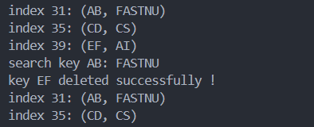

TASK 07
#include <iostream>
#include <string>
using namespace std;

void bruteForceSearch(string text, string pattern) {
int n = text.length();
int m = pattern.length();
for (int i = 0; i <= n - m; i++) {
int j = 0;
while (j < m && text[i + j] == pattern[j]) {
j++;
}
if (j == m) {
cout << "Pattern found at index " << i << endl;
return;
}
}
cout << "No " << pattern << " hehe" << endl;
}

int main() {
string text = "abracadabra";
string pattern = "abra";
bruteForceSearch(text, pattern);
bruteForceSearch(text, "life");
return 0;
}
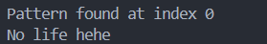

TASK 08
#include <iostream>
#include <string>
using namespace std;

#define d 256

void rabinKarp(string text, string pattern, int q) {
int m = pattern.length();
int n = text.length();

int p = 0;
int t = 0;
int h = 1;

for (int i = 0; i < m - 1; i++) {
h = (h * d) % q;
}

for (int i = 0; i < m; i++){
p = (d * p + pattern[i]) % q;
t = (d * t + text[i]) % q;
}

for (int i = 0; i <= n - m; i++) {
if (p == t) {
int j;
for (j = 0; j < m; j++) {
if (text[i + j] != pattern[j]) {
break;
}
}
if (j == m) {
cout << "Pattern found at index " << i << endl;
return; // Stop after first occurrence
}
}

if (i < n - m) {
t = (d * (t - text[i] * h) + text[i + m]) % q;
if (t < 0) {
t = t + q;
}
}
}
}

int main() {
string text = "Wabalabadubdub";
string pattern = "abad";
int q = 101;

rabinKarp(text, pattern, q);

return 0;
}



